SJTU User Manual of Online Teaching Platform via Livestreaming and Recorded Videos (For Teachers)
(This is a translation of the original version in Chinese. If there is any discrepancy, the Chinese version shall prevail.)
- Login to the Platform
The online teaching website of Canvas@SJTU is: https://oc.sjtu.edu.cn. Click “login for on-campus users with jAccount”.
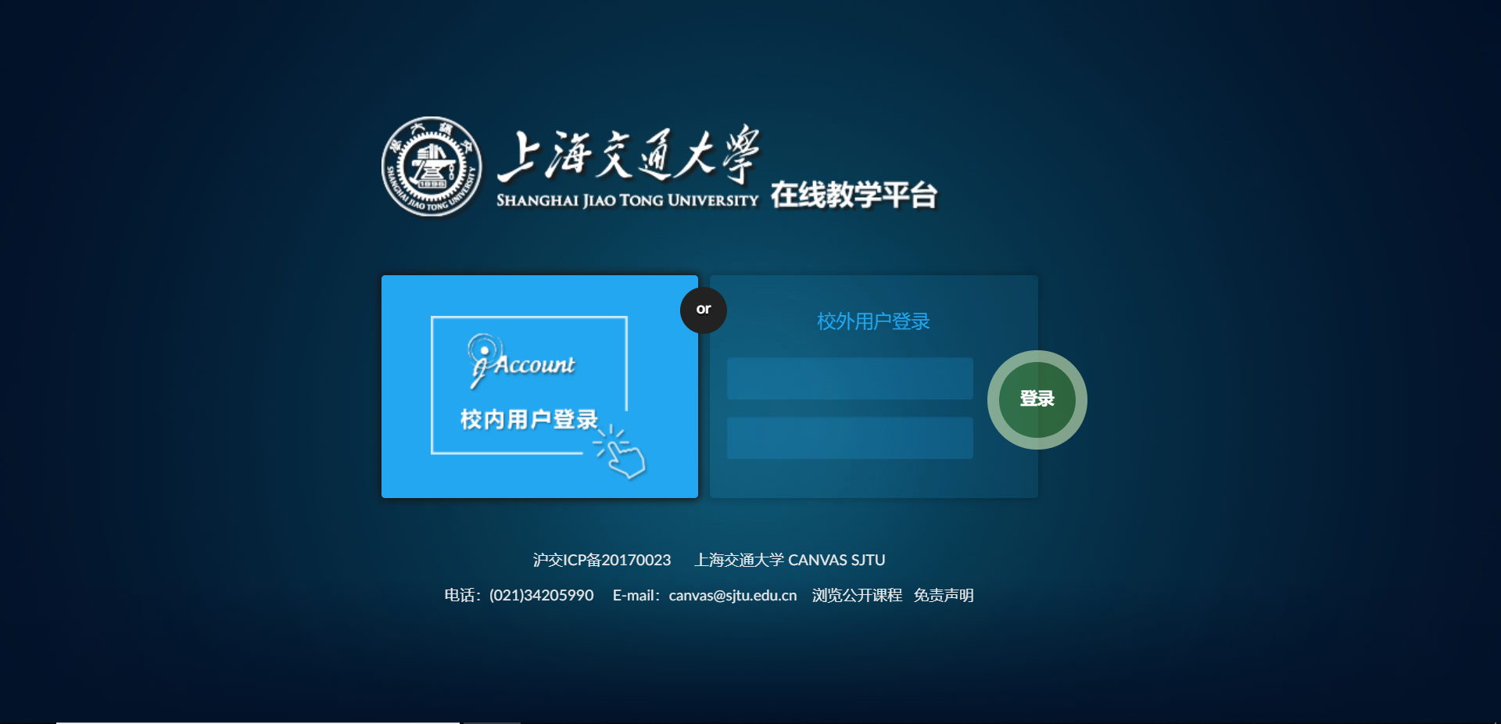
login for on-campus users with jAccount

2. If you have courses to deliver this semester, the control panel of the platform will display all of them. Click the course name, and click the "recorded courses” tag in the left tab bar (as shown in the picture below). The platform will show the lectures that were recorded in the classroom in the form of a list on the right section. No matter what the status of the course is, teachers can click the corresponding video to view and download.

Rights management of recorded courses: After the video-on-demand (VOD) is available, it is open for use by default. Based on your needs, you can choose whether to keep the course video open to students for VOD or not (please check the "□" before a certain video and select either“open”or“not open”). If a green label appears after the course information, it means that the course VOD of the session is open; if a red label is displayed, it means the course VOD of the session is not open.

Download course videos: Teachers can click the “video download” button in the lower right corner of the video to download the course video of the corresponding session.

Other functions (still under development): It is intended that, in the future, teachers can do basic editing to each video of their courses, and edit the title of each course, etc.
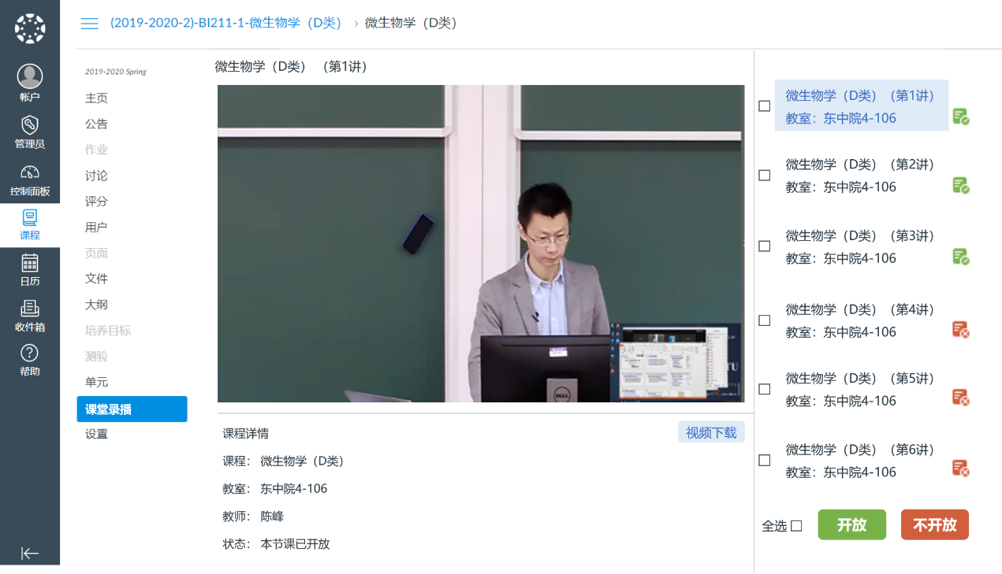
Video download
not open
open
courses
Recorded courses

Please note:
- Due to data synchronization, students joining the lectures only with teachers’ invitation will not have the right to access VOD and only those who have formally selected the course in the educational administration system can access VOD and livestreaming courses.
- The platform is still development, and if the interface changes, please refer to the actual one.

SJTU User Manual of Online Teaching Platform via Livestreaming and Recorded Videos (For Students)

1. Login to the Platform
The online teaching website of Canvas@SJTU is: https://oc.sjtu.edu.cn. Click “login for on-campus users with jAccount”.
login for on-campus users with jAccount

2. View the courses
On the control panel, you can find the courses your teachers have posted on Canvas this semester.

If some of the courses you have selected are not shown on the control panel, you can click “courses” and then “all the courses” to see the list of all the courses you have selected this semester. If the status of a course is “yes”, it means the teacher has opened the course materials for use and you can enter the part and view relevant materials; if the status is “no”, it means the teacher has not yet opened the course materials for use and you can contact him/her directly.
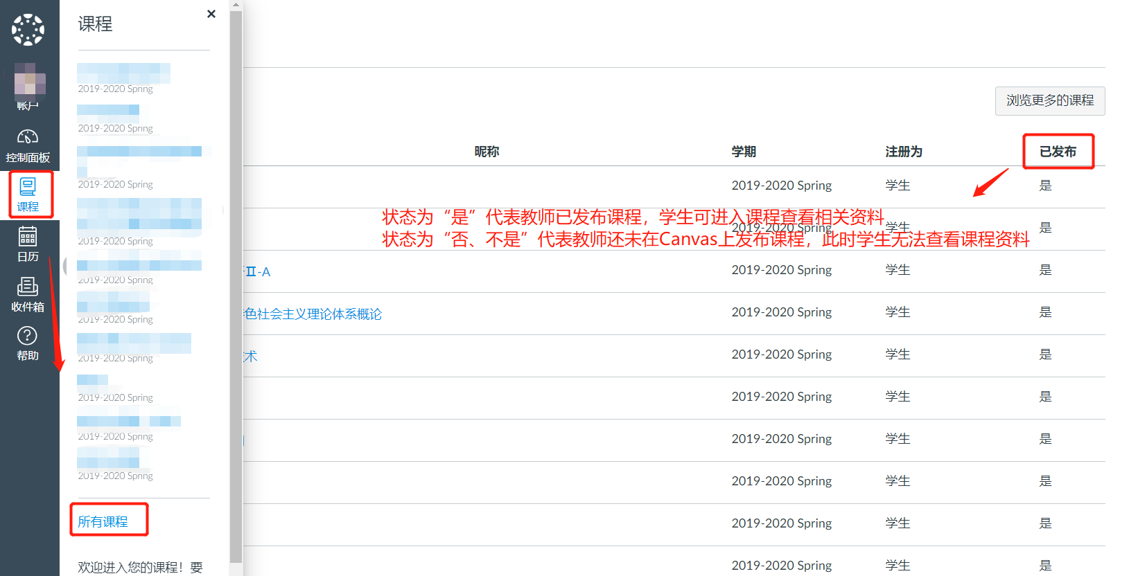
yes
all the courses
courses
If the status of the course is “yes”, it means the teacher has opened the course materials for use and you can enter the part and view relevant materials; if the status is “no”, it means the teacher has not yet opened the course materials for use and you cannot access the materials.

3. View courses VOD/ livestream courses
Click and enter your courses, and then click the "recorded courses” tag in the left tab bar (as shown in the picture below) to view the video-on-demand (VOD) and livestream courses.

Course VOD: You can view the course VOD your teachers have opened on the VOD interface.

Livestreaming courses: The system will present to you the schedule of courses that will be livestreamed within the next three days (from the present time). You can watch the live broadcast according to schedule. Before the scheduled livestream time, the interface will show "no livestream courses available at present”(目前暂无直播课程).
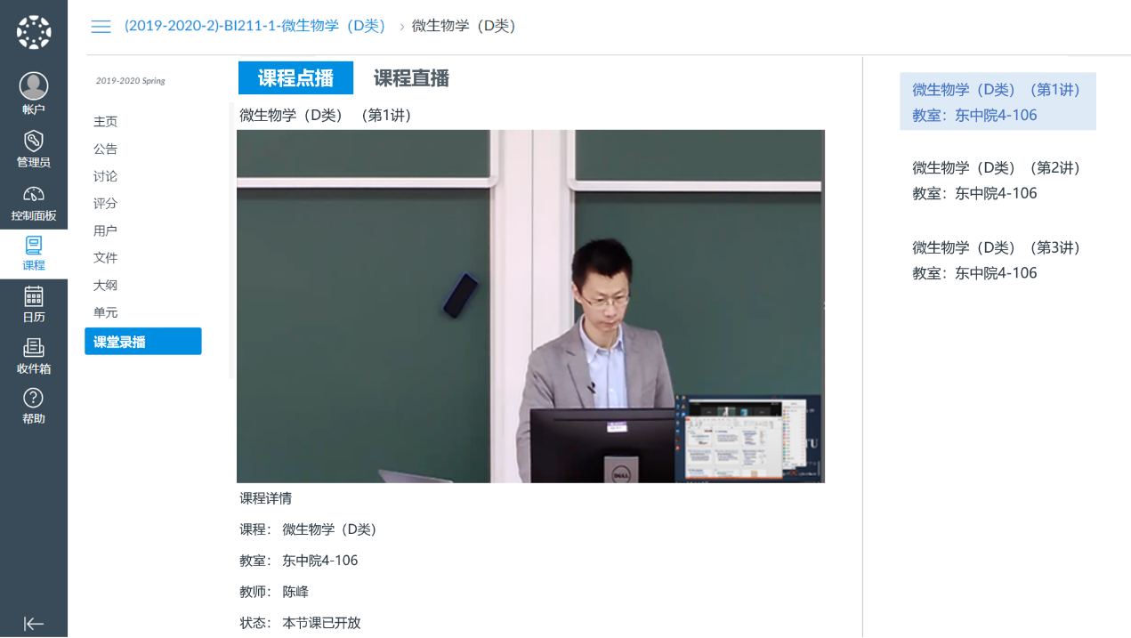
livestream
courses
course VOD
recorded
courses
courses
The Interface of Course VOD

Please note:
- Only those who have formally selected the courses in the educational administration system can access VOD and livestreamed courses.
- The availability of a certain session of the course VOD depends on whether the teacher has opened it to you.
- The platform is still under development, and if the interface changes, please refer to the actual one.

